CELEBRATING OUR BELOVED COMMUNITY
2018 Sponsorship Form

Organization Name
 |  |  | Please provide your organization’s name as it should be listed in print.
Organization Address
 |  |  | City |  |  |  | State | Zip
Sponsorship Contact Name
 |  |  |  | Please list the organization contact for this sponsorship.
Phone # |  |  |  |  | Email
Logo/Artwork Contact Name
 |  |  |  | Please list the contact for logos and artwork, if applicable.
Phone # |  |  |  |  | Email

Please mail, fax or email this form to:
Mail: Katie Knipe
COBC Sponsorship
Over-the-Rhine Community Housing
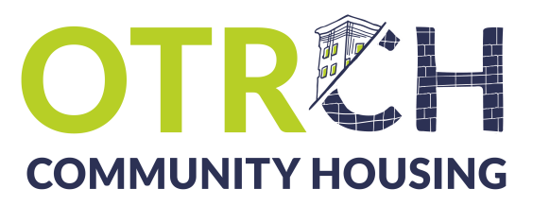
114 West 14th St.
Cincinnati, OH 45202

Email: kknipe@otrch.org
Fax: 513-381-1314
Thank you for your support!
Phone: 513-381-1171 ext. 117
Payment:
Payment may be submitted online at http://weblink.donorperfect.com/CelebratingOurBelovedCommunity.
Checks may be made out to Over-the-Rhine Community Housing and mailed to the address above.

